Passport Management System
Class Diagram:
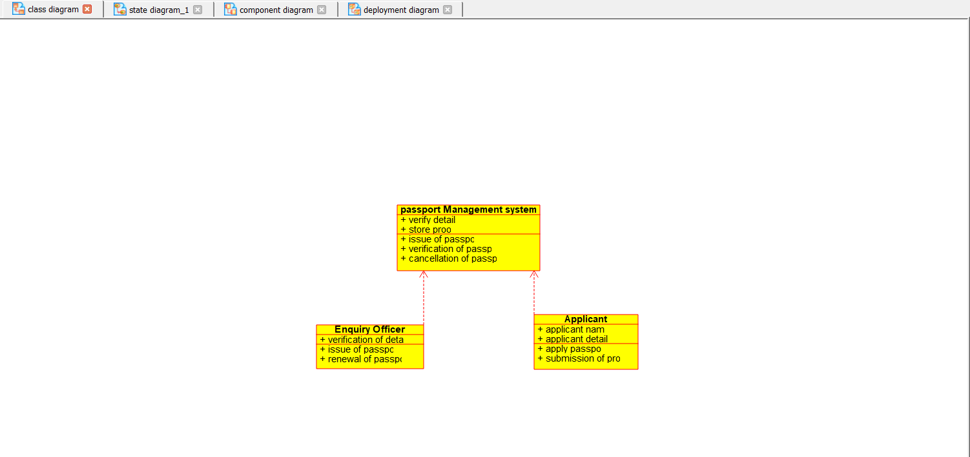

State Diagram:
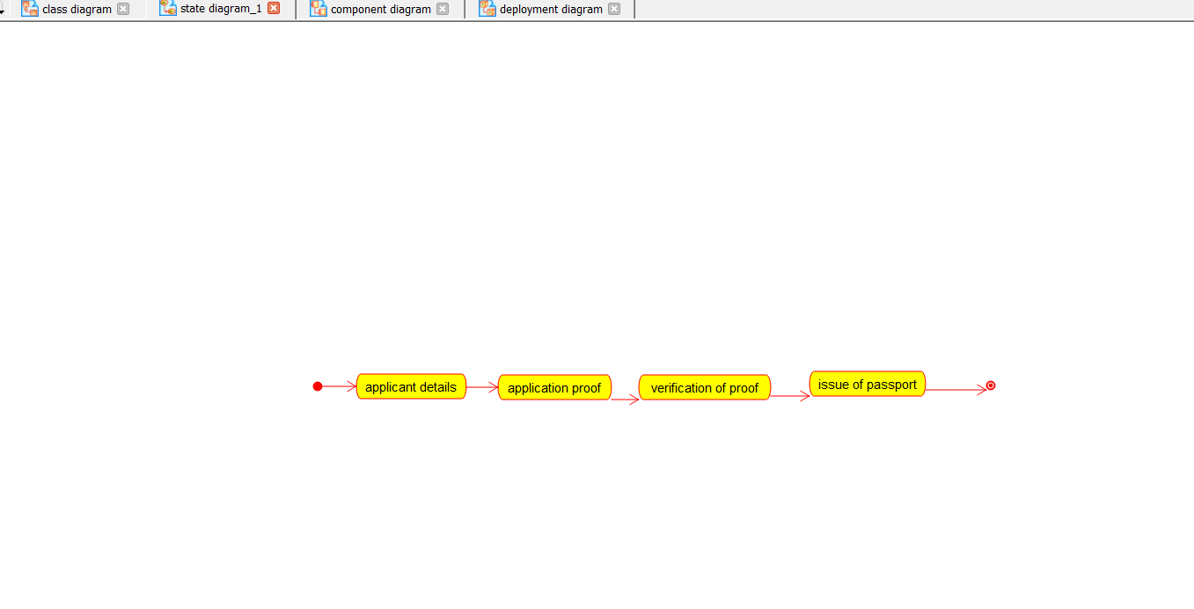

Component Diagram:
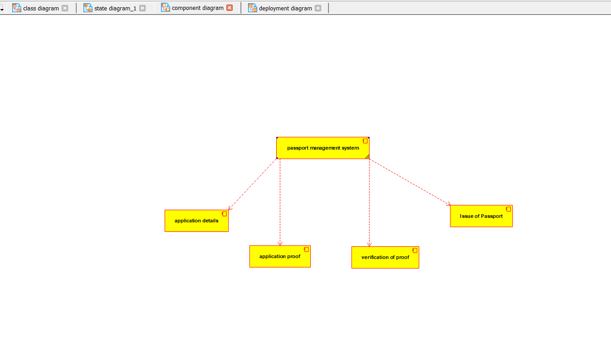

Deployment Diagram:
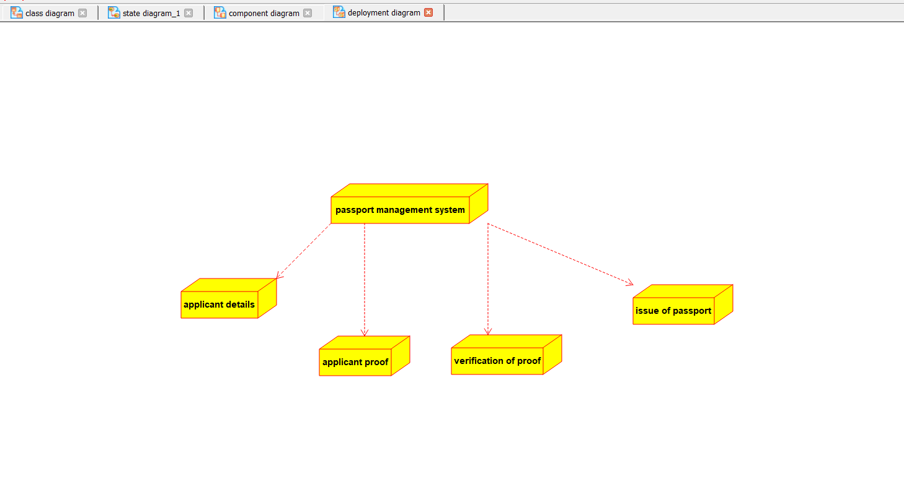

Use Case Diagram:
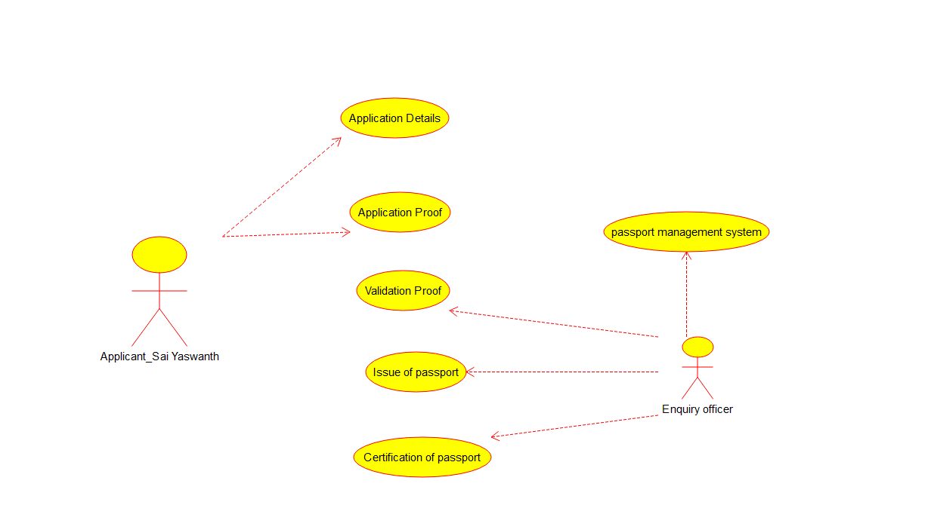

Sequential Diagram:
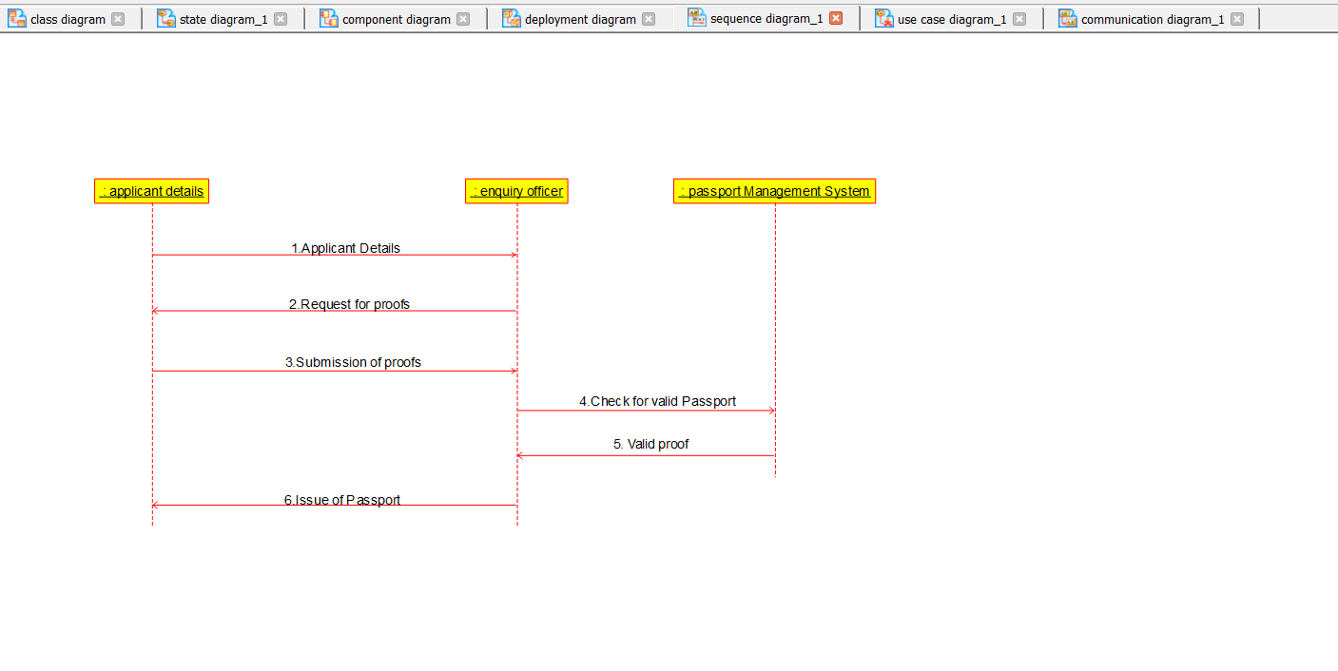

Activity Diagram:
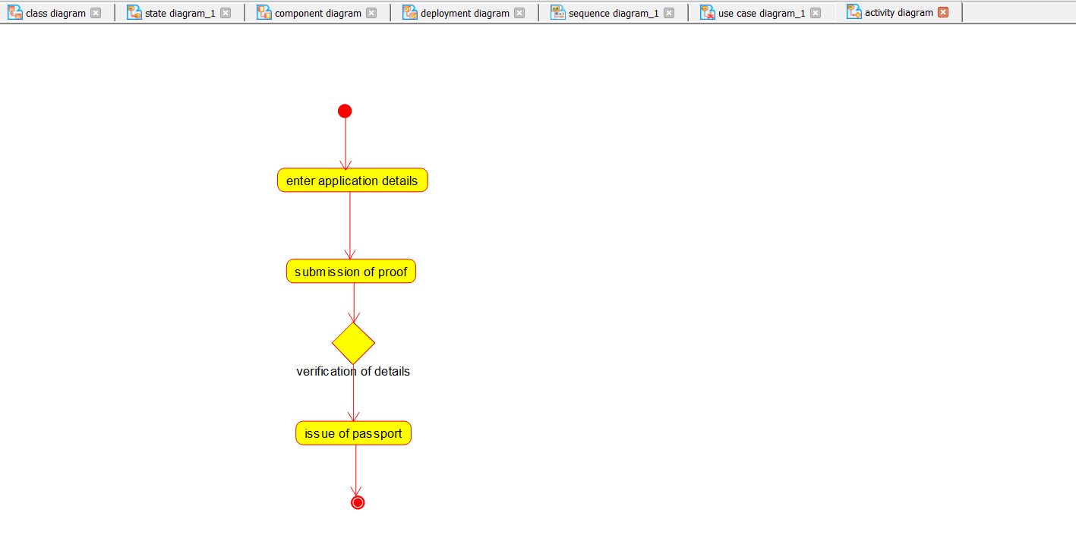
Applicant.
#include "Applicant.h"

// Constructors/Destructors
//

Applicant::Applicant () {
initAttributes();
}

Applicant::~Applicant () { }

//
// Methods
//

// Accessor methods
//

// Other methods
//

void Applicant::initAttributes () {
}

Enquiry_Officer
#include "Enquiry_Officer.h"

// Constructors/Destructors
//

Enquiry_Officer::Enquiry_Officer () {
initAttributes();
}

Enquiry_Officer::~Enquiry_Officer () { }

//
// Methods
//

// Accessor methods
//

// Other methods
//

void Enquiry_Officer::initAttributes () {
}
passport_Management_system
#include "passport_Management_system.h"

// Constructors/Destructors
//

passport_Management_system::passport_Management_system () {
initAttributes();
}

passport_Management_system::~passport_Management_system () { }

//
// Methods
//

// Accessor methods

// Other methods
//

void passport_Management_system::initAttributes () {

